**Bug Report**

**Title:** No Error Message Displayed When "Message" Field is Empty

**Summary:** When submitting the contact form on the "Contact Us" page, if the "Message" field is left empty, no error message is displayed, allowing the form submission to proceed without providing a necessary message.

**Steps to Reproduce:**

1. Navigate to the "Contact Us" page at <https://www.tendable.com/contact-us>.
2. Click on Contact for "Marketing" section, and complete the form excluding the "Message" field.
3. Fill in all required fields except the "Message" field.
4. Click on Agree and "Submit" button.

**Expected Result:** An error message should be displayed indicating that the "Message" field is required.

**Actual Result:** No error message is displayed, and the form submission is allowed to proceed without a message.

**Environment:**

* Browser: Chrome
* Operating System: Windows 11
* URL: <https://www.tendable.com/contact-us>

**Severity:** Medium

**Attachments:** 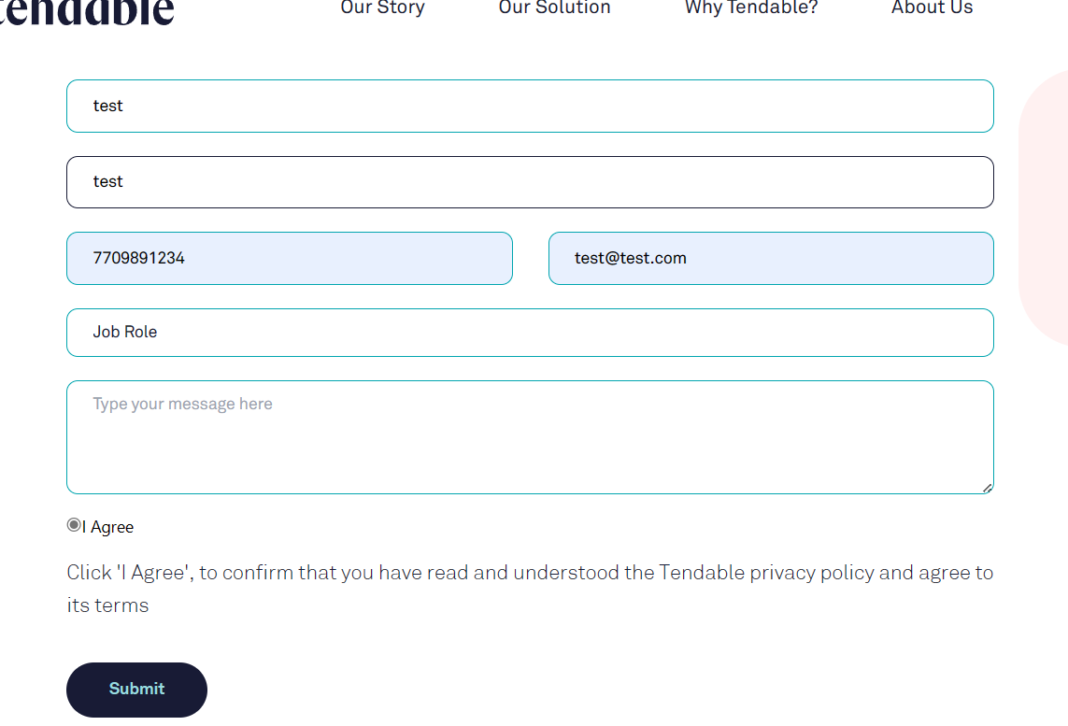

**Additional Notes:** This issue may lead to incomplete form submissions, impacting user communication and data integrity.